***Student Name: Muhammed Arsath C.N.***

***Seat No: 250***

***Project Id: 10***

***Project Title: Review Scheduling Portal for TAC***

**Technical Components:**

|  |  |
| --- | --- |
| Components | Tech Stack |
| 1. Frontend | React Js |
| 1. API | Rest API |
| 1. Backend | Spring Boot |
| 1. Database | MYSQL |

**Implementation TimeLine:**

|  |  |  |  |
| --- | --- | --- | --- |
| Phase | Deadline | Status | Notes |
| Stage 1 | 06-06-2024 | Completed | Planning and Requirement Gathering |
| Stage 2 | 22-08-2024 | Completed | Design and prototyping |
| Stage 3 | - | Completed | DB Designing |
| Stage 4 | - | Completed | Backend Implementation |
| Stage 5 | - | Not Completed | Testing & Implementation |

**1.PROBLEM STATEMENT:**

Review Scheduling Portal for TAC: Build the system to schedule the review for the booked appointments domain wise.

**2.WORK FLOW:**

**2.1. User Login:**

* + Users (students, teachers, admins) can Login to the portal using their Institute mail id (Bitsathy) only.
  + User’s (students, teachers, admins) can be inserted in the database.

**2.2. Appointment Booking:**

* + Students can book appointments with teachers for reviews in specific domains.
  + Teachers can view and manage their available slots for booking.

**2.3. Slot Booking:**

* + Students can select an available slot for a review in a particular domain.
  + The system should prevent students from booking more than one slot per domain.

**2.4. Review Scheduling:**

* + After booking, the student's appointment is confirmed, and the review is scheduled.
  + The review will be schedule based on one Teacher for 10 students.
  + If the slot is over, it will not show to the students and teachers.

**2.5. Admin Dashboard:**

* + Admins have access to a dashboard to manage users, appointments, and reviews.
  + Admins can add, edit, or delete users, domains, and review slot.

**4.FLOW CHART:**

**Student and Teacher Flow**

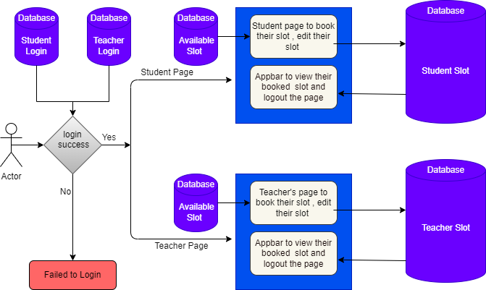

**Admin Flow**

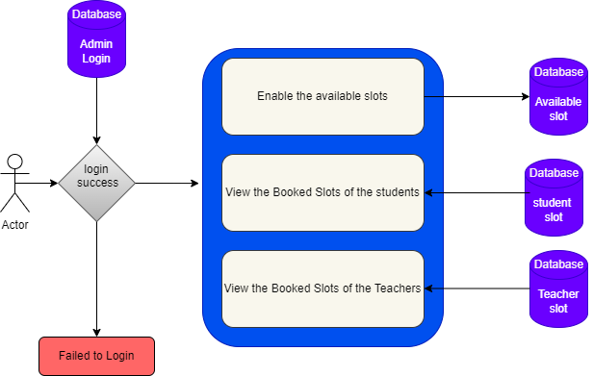

5.CODE (FRONTEND):

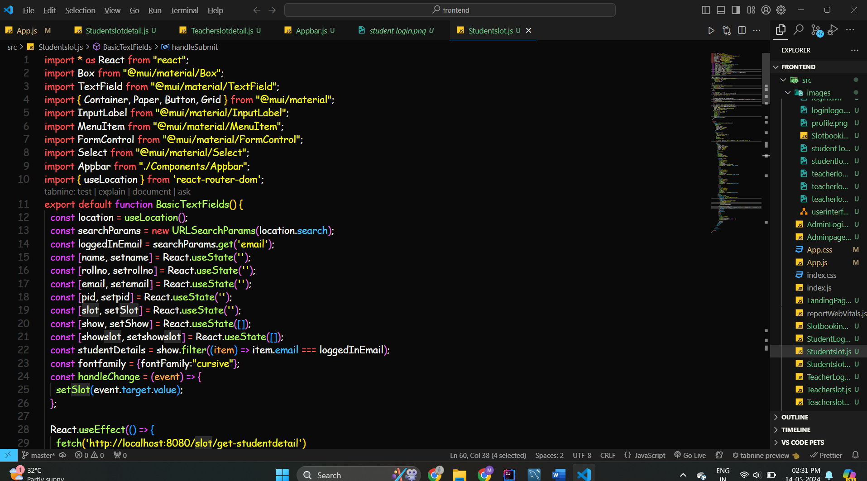

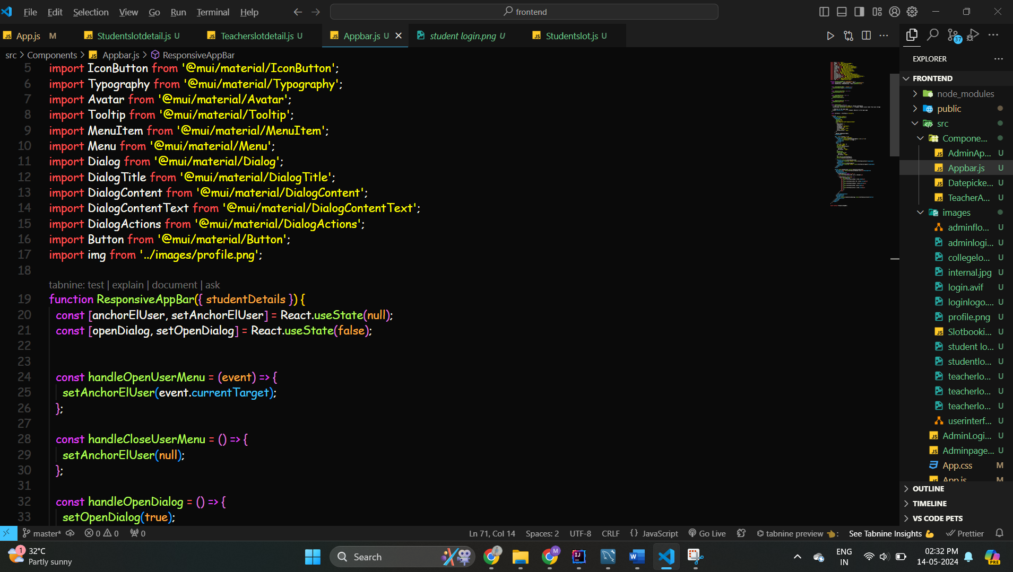

5.2 CODE(BACKEND):

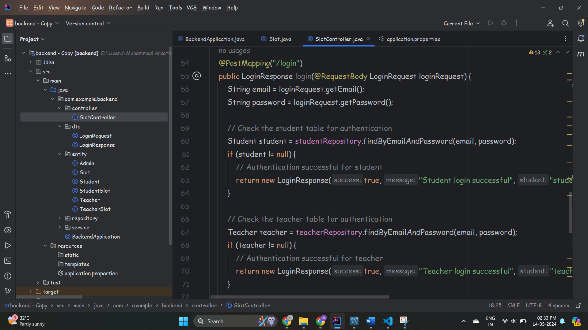

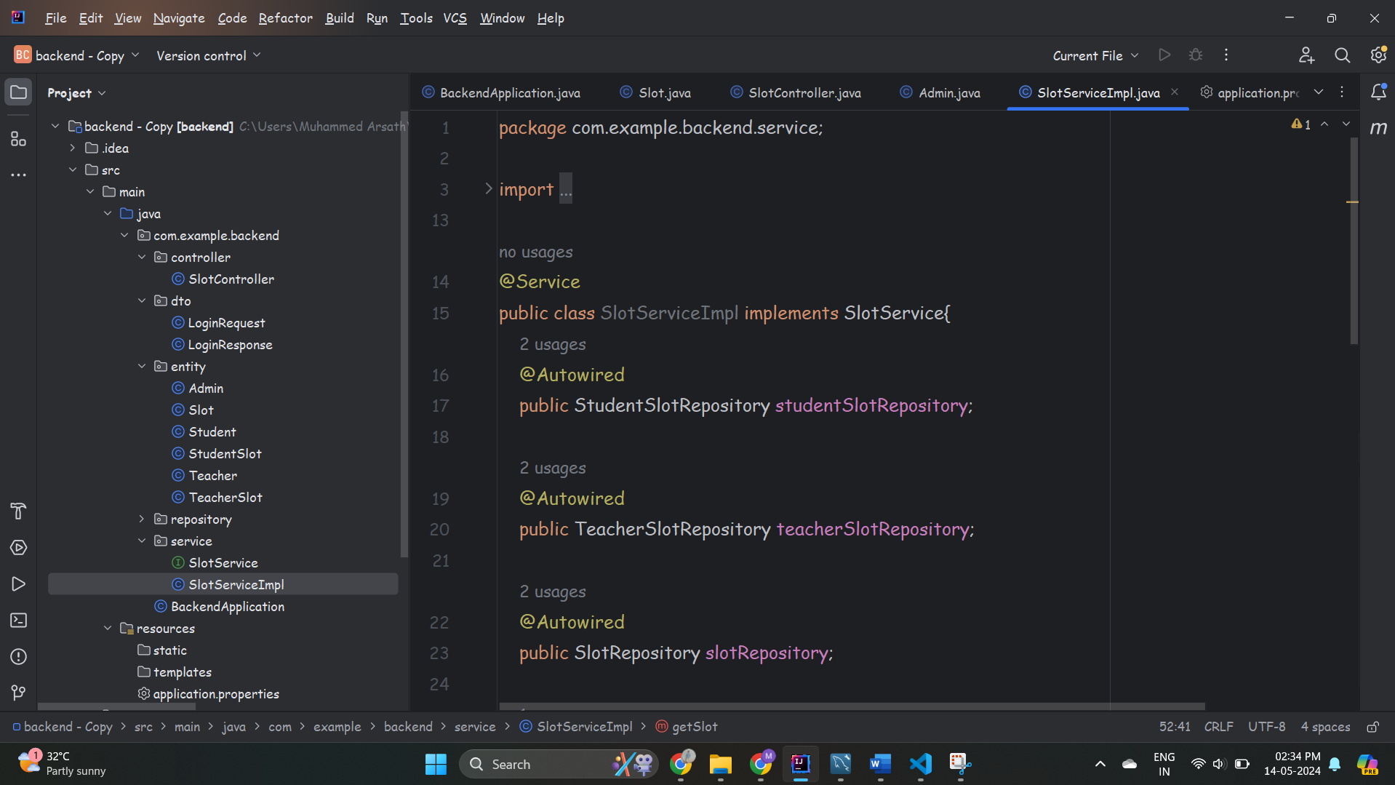

6.PROJECT OUTPUT:

